Defining the Application Architecture
Project Title
Smart Lender – Applicant Credit Prediction System

1. Introduction
The Smart Lender – Applicant Credit Prediction System is a machine learning-based web application that predicts whether a loan application is likely to be approved or rejected based on applicant information. The application uses a trained Random Forest model integrated with a Flask web application to provide real-time predictions through a simple web interface.
To improve maintainability, scalability, and code organization, the application follows a Three-Tier Architecture. The project is organized into separate modules for data storage, model training, frontend development, backend processing, and deployment resources.

2. Application Architecture
The Smart Lender system follows a Three-Tier Architecture consisting of:
- Presentation Layer
- Application Layer
- AI/ML Service Layer
This architecture separates the responsibilities of the application into independent modules, making future enhancements easier.

3. Three-Tier Architecture
3.1 Presentation Layer (Frontend)
The Presentation Layer provides the user interface through which users interact with the application.
Components
- HTML Pages
- CSS
- Images
- Templates Folder
- Static Folder
Responsibilities
- Display loan application form
- Collect applicant details
- Send user input to Flask backend
- Display prediction result
Files Used
- templates/
- static/

3.2 Application Layer (Backend API)
The Application Layer is implemented using the Flask framework.
Main File
app1.py
Responsibilities
- Receive user input
- Validate submitted data
- Load StandardScaler
- Load Random Forest Model
- Perform prediction
- Return result to frontend
The Flask application acts as a bridge between the frontend and the machine learning model.

3.3 AI/ML Service Layer
The AI layer performs prediction using trained machine learning models.
Components
- rdf.pkl
- scale1.pkl
Responsibilities
- Scale input features
- Predict loan approval
- Return prediction to Flask
The trained Random Forest model is stored as rdf.pkl, while the StandardScaler is stored as scale1.pkl.

4. Project Directory Structure
SmartLender
│
├── Dataset
│ ├── loan_prediction.csv
│ ├── loan_prediction.xlsx
│ └── loan_prediction(1).csv
│
├── Flask
│ ├── static
│ ├── templates
│ ├── app1.py
│ ├── app1(1).py
│ ├── rdf.pkl
│ ├── scale1.pkl
│ └── scale1(1).pkl
│
├── IBM
│
└── Training
└── Loan Prediction using ML.ipynb

5. Description of Project Modules
Dataset Folder
The Dataset folder stores the loan applicant dataset used for training and testing the machine learning model. The dataset contains applicant information such as gender, marital status, education, income, loan amount, credit history, and loan status.

Training Folder
The Training folder contains the Jupyter Notebook used during model development.
Functions performed:
- Load dataset
- Handle missing values
- Data preprocessing
- Feature engineering
- Train Random Forest model
- Evaluate model
- Save trained model
- Save StandardScaler

Flask Folder
The Flask folder contains the complete web application.
app1.py
Main backend application responsible for:
- Starting Flask server
- Loading trained model
- Loading scaler
- Receiving user input
- Performing prediction
- Returning result
templates
Contains HTML pages used as the application's user interface.
static
Contains CSS, images, and other frontend resources.
rdf.pkl
Stores the trained Random Forest model used for prediction.
scale1.pkl
Stores the StandardScaler used to normalize user input before prediction.

IBM Folder
The IBM folder contains cloud deployment resources and configuration files used during deployment.

6. Application Workflow
The overall workflow of the Smart Lender application is as follows:
- User opens the Smart Lender web application.
- User enters loan applicant details.
- HTML form sends data to the Flask application.
- Flask receives the request.
- Flask loads the StandardScaler.
- User input is scaled.
- Flask loads the trained Random Forest model.
- Model predicts loan approval status.
- Prediction result is returned to Flask.
- Flask displays the result on the web page.

7. Data Flow
User

↓

HTML Form (templates)

↓

Flask Backend (app1.py)

↓

StandardScaler (scale1.pkl)

↓

Random Forest Model (rdf.pkl)

↓

Prediction Result

↓

Display to User

8. Modular Design
The Smart Lender application is designed using a modular architecture.
- Dataset is stored separately.
- Training code is isolated in a notebook.
- Backend logic is implemented in app1.py.
- Frontend files are maintained separately.
- Machine learning model is stored independently.
- Styling resources are stored in the static folder.
This modular design improves code readability and maintenance.

9. Scalability
The architecture supports future enhancements such as:
- Adding new machine learning models
- Database integration
- User authentication
- REST API development
- Cloud deployment
- Mobile application integration

10. Advantages of the Architecture
- Modular design
- Separation of concerns
- Easy maintenance
- Better scalability
- Faster development
- Reusable components
- Easy debugging
- Independent frontend and backend
- Improved project organization

11. Conclusion
The Smart Lender – Applicant Credit Prediction System follows a well-structured three-tier architecture that separates the presentation layer, backend processing, and AI/ML prediction services. The modular directory structure enhances maintainability, scalability, and future extensibility. This architecture enables efficient development, easier testing, and smooth deployment of the application.
12.Final Architecture Diagram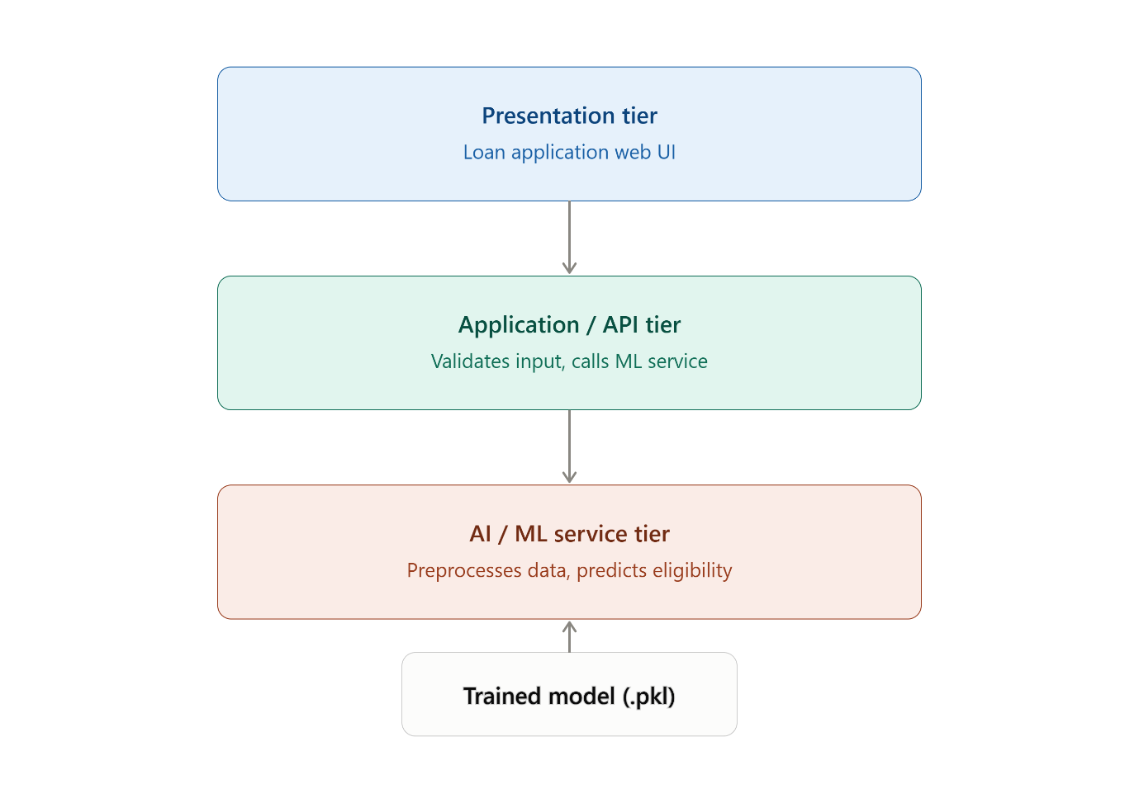
13.Running Application
